Combine Queries
Combining more than one queries either horizontal or vertical we call it as Combine Queries. Result of a combine operation on one or more queries will be only one query. You can find Append Queries or Merge Queries in the Combine Queries section of the Query Editor in Power BI. Append Queries will combine the queries data vertically. Merge Queries will combine the queries data horizontally.
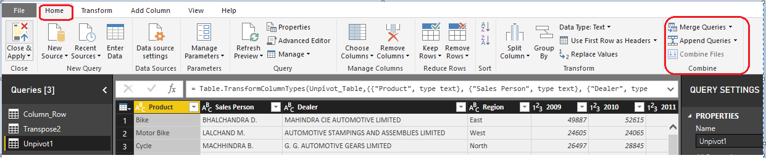
Append Queries
Append Queries means results of two (or more) queries will be combined vertically into one query in the below way
Rows will be appended after each other. (For example appending a query with 50 rows with another query with 100 rows, will return a result set of 150 rows)
Each Query should contain same number of columns and same datatype for columns for better outputs. (For example col1, col2… col10 in first query, after appending with same columns in the second query will result into one query with single set of col1, col2… col10)
Append 2 files individually with different queries
Consider two sample data sets, one for each month sales,
Sales for April Month


Sales for May Month


To append these queries, click on one of them and select Append Queries from the Combine section of Home tab in Query Editor.
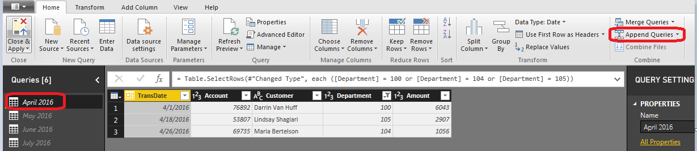
If you want to keep the existing query result as it is, and create a new query with the appended result choose Append Queries as New, otherwise just select Append Queries. In this example I’ll do Append Queries as New, because I want to keep existing queries intact.
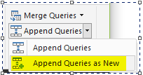
You can choose what is the primary table (normally this is the query that you have selected before clicking on Append Queries), and the table to append. In the append query result you will see primary table values first and others next.
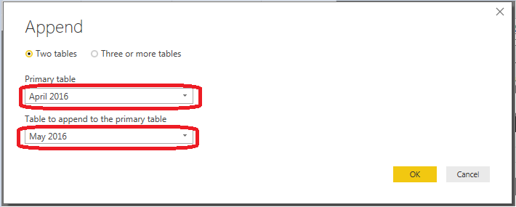

For this example, I have only two tables, so I’ll continue with above configuration. Append Queries simply append rows after each other, and because column names are exactly similar in both queries, the result set will have same columns.
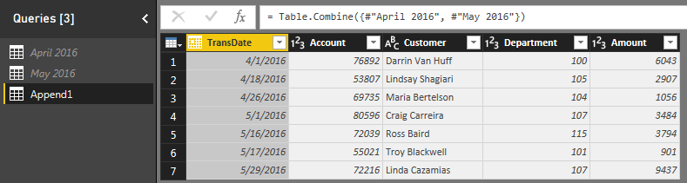

Result of Append as simple as below. Append is similar to UNION ALL in T-SQL.
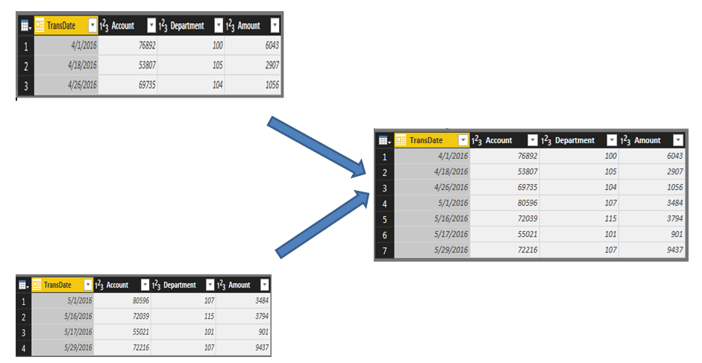
What if files contain duplicates?
Append Queries will NOT remove duplicates. You have to use Group By or Remove Duplicate Rows to get rid of duplicates.
What if the Columns in the query are not matched exactly?
Append requires columns to be exactly similar to work in best condition. If columns in source queries are different, append still works, but will create one column in the output per each new column, if one of the sources doesn’t have that column the cell value of that column for those rows will be null.
Append 3 or more files individually with different queries
Open Edit Queries as shown below.
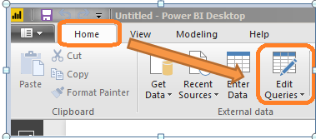
Query Editor Will opens → From Home Tab → selects New Source → Select the type of source for example Text/CSV as shown below → Browse for the file location → Select the file → Open.
Apply all steps above for each file to get multiple files into Query Editor for Appending.
Now all the three files are there in Query Editor as shown below. Now we will see how to append them.

Select Append Queries → Under select Append Queries as New

Select three or more tables → Add tables from Available tables section to Tables to append section
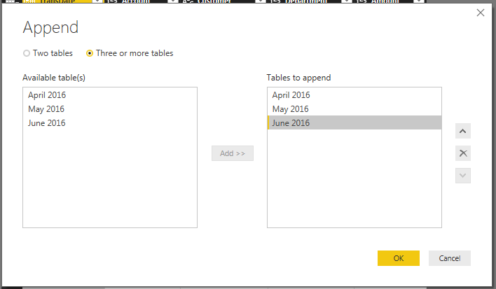

Change the order using up and down button as shown in above image, the way you are expecting the data in append query result→ Ok. Now you will see an Append Query with the data from all the three files we selected in the same order as we placed in Tables to append section as shown below.
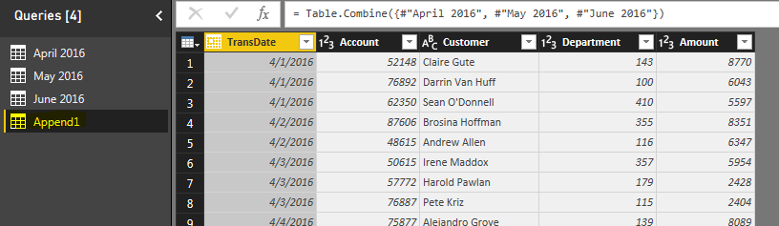

Appending multiple files of same type from a folder using single query
In the above example we append April, May and June files. Tomorrow let us assume we get a file for July Month. In the above process you need to import it manually and need to append all the four files. It’s a manual and lengthy process. Let’s see how we can automate it by a single refresh and how to import and append with single query.
Open Query Editor → Home → New Source → More...
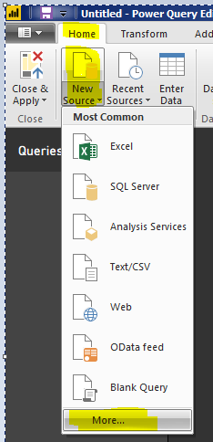

Select Folder → Connect → Enter the folder Path where files are located
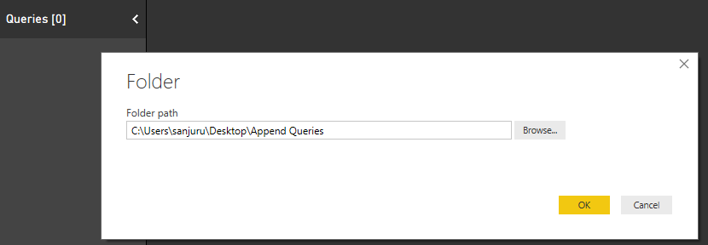
Select Ok → Edit → Perform Transformation Steps as shown below.
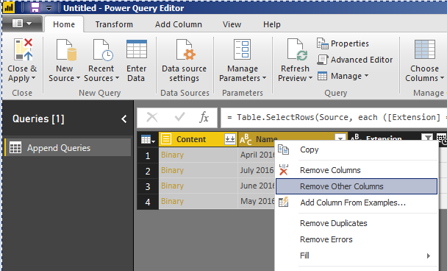
Select two down arrows to combine files as shown in below image
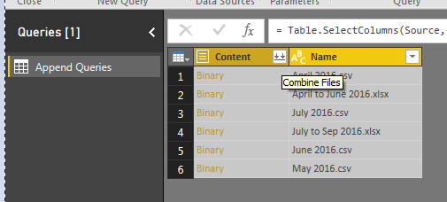
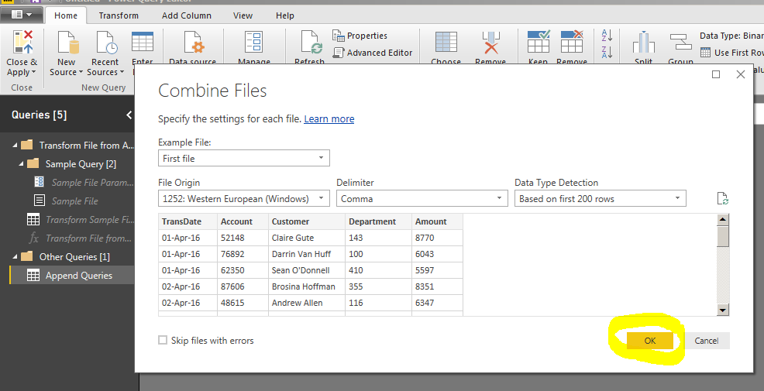

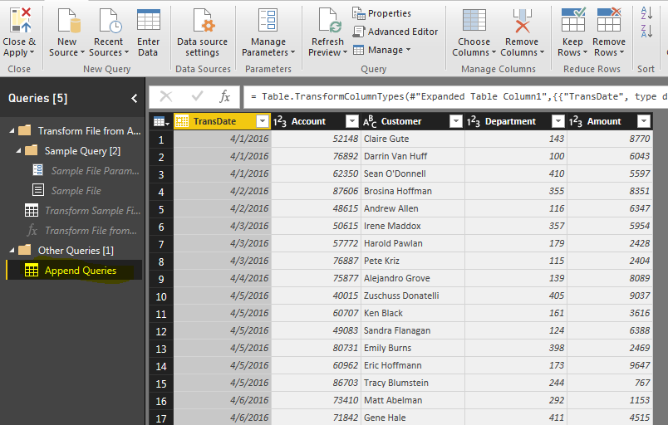

Tomorrow when you get a new file, place it in the folder and simply refresh in Query Editor. You will find updated data in Append Queries section.
Task
Append the data from multiple excel sheets in an excel workbook and multiple workbooks or files in folder with a single query.
Add a Custom Column with the below formulae to read the content from excel workbook.
Excel.Workbook([Content])
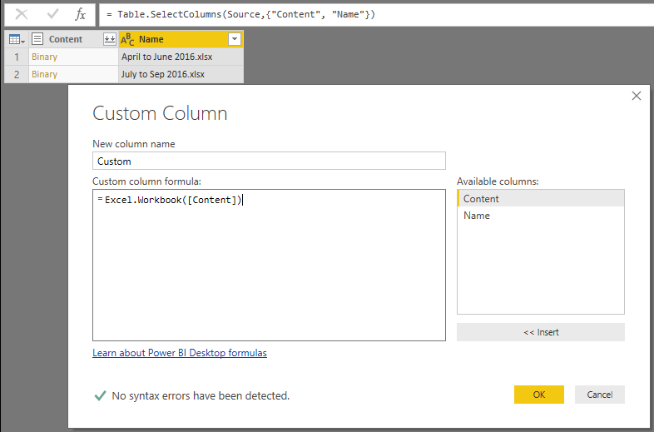

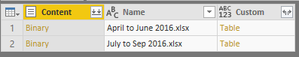



Right-click options of a Query
When you right-click on the name of a query (in the left-most pane of Power Query's window) you will see list of options a show below. We will discuss each of them now.
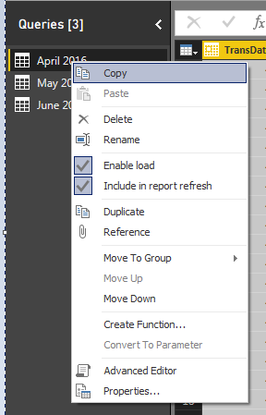
Copy
Copy option will copy the query and you can paste the query where ever you needed.
Paste
Paste is used to paste the copied query under the queries section.
Delete
Delete is used to delete a particular Query.
Rename
Rename will help you to rename a query.
Enable Load
Always remember that Query Editor is your ETL (Extract, Transform, and Load) engine. It will apply all transformations before loading the data into the model, but once you finished the transformation all queries will be loaded into the model and they take memory. By default, all queries are enabled to Load into the model. Simply change that for queries that are not required in the model by disabling the option “Enable Load”.
"Enable Load" means query results are available for report builder. Otherwise you may use it in your other queries (for example to merge data), but it is not shown in the report builder.
Include in report refresh
"Include in Report Refresh" means query is automatically refreshed when you press "Refresh" button on the ribbon. Disable this option for the static tables to improve the performance of report refresh.
Duplicate Query
Duplicate will duplicate the code of the query. Duplicate is generally used when you would like to create a similar query and you do not want to type the same code. Once you created a duplicate query from source query then duplicate query is independent of source query. You can make changes to this duplicate query.
Reference Query
Reference Query means you would like to use that Query results in some other queries where your original query remains as a base Query. Once you created a reference query from source query then reference query is dependent of source query. When you make changes to source query those will reflect in reference query. You can make additional changes to this reference query.
